Name: Soumyadip Ghosh

Stream: CSE -A

Roll Number: 1951007

Subject: Microprocessors Lab

Date of Lab: 26.08.21

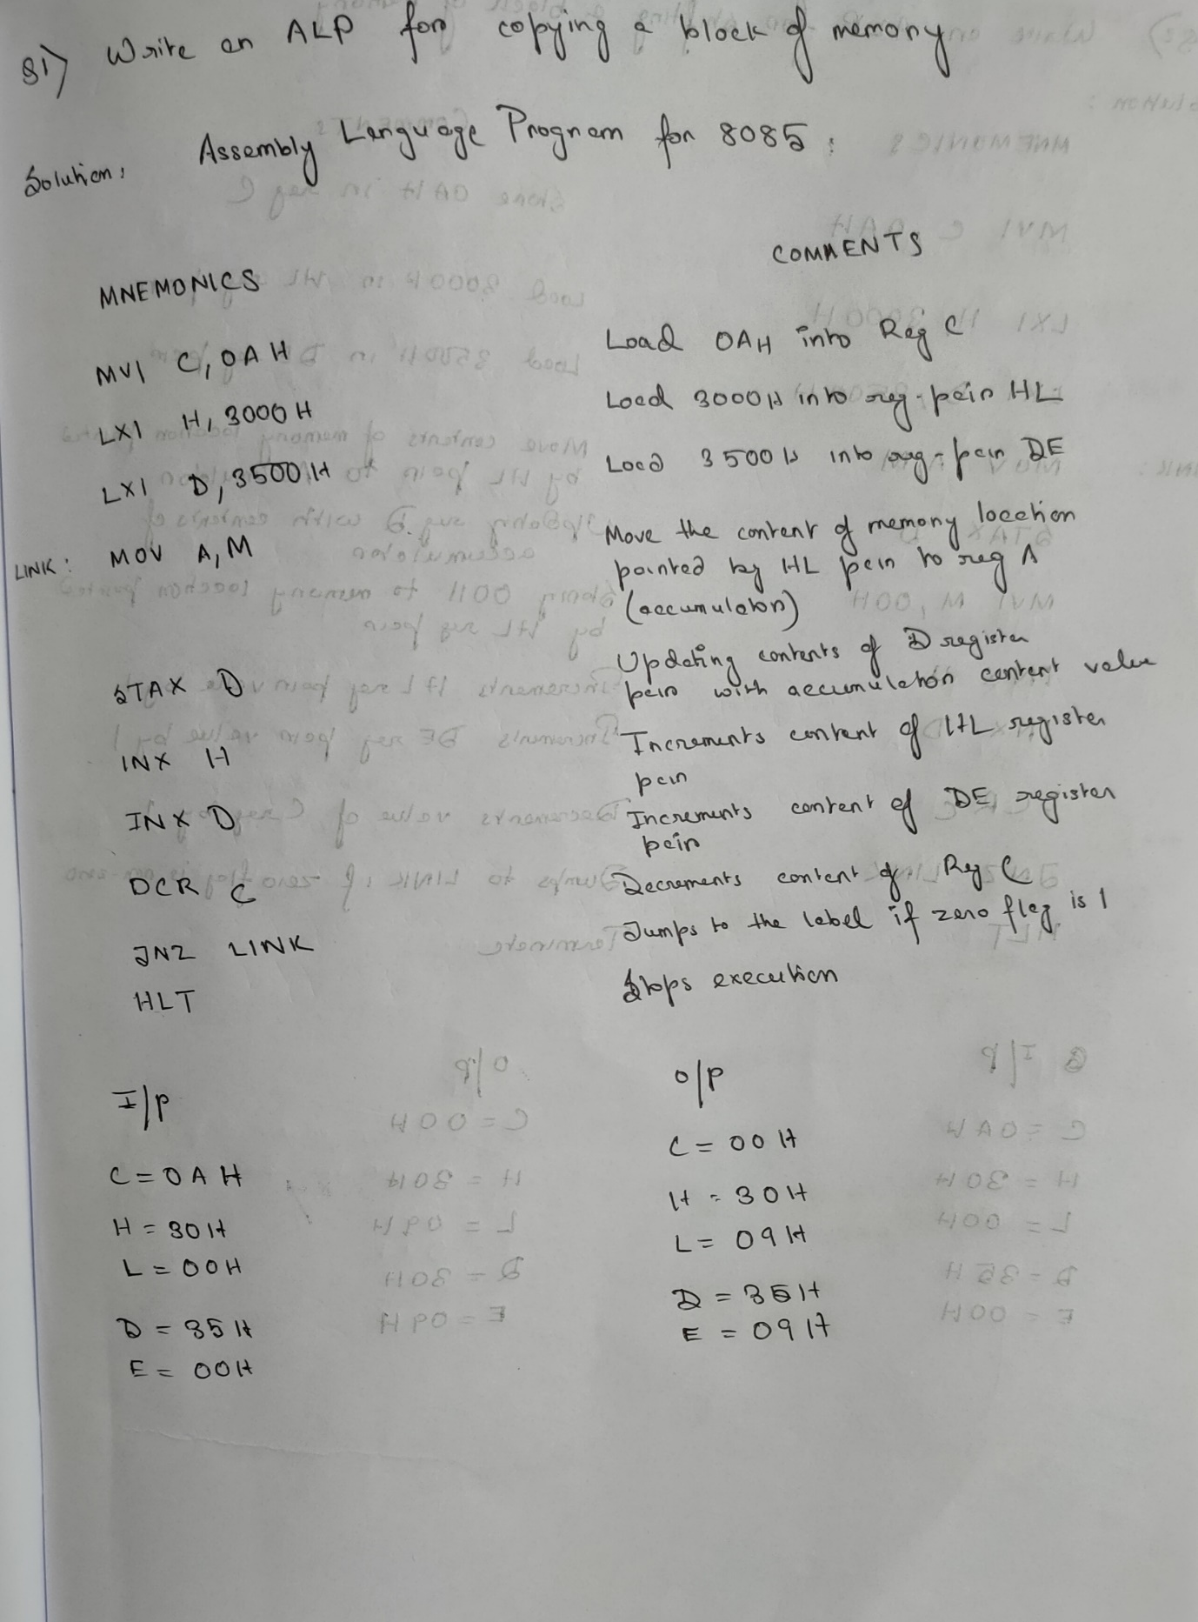

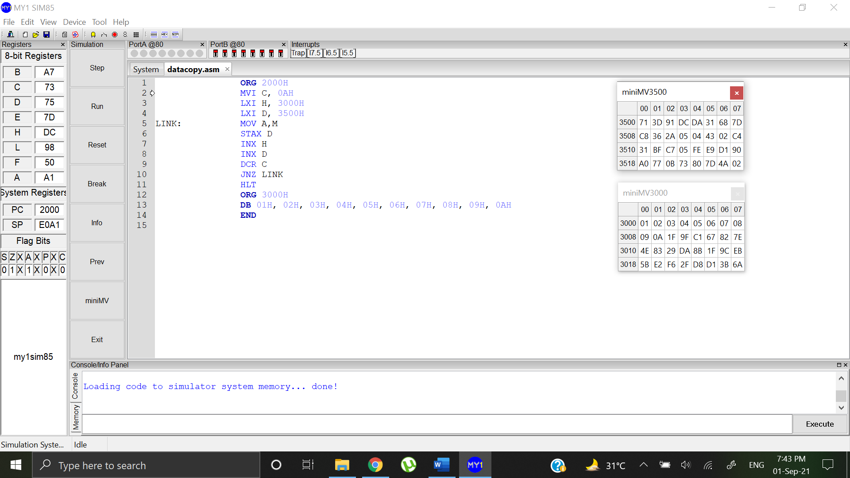

MV values before copying MV value after copying

 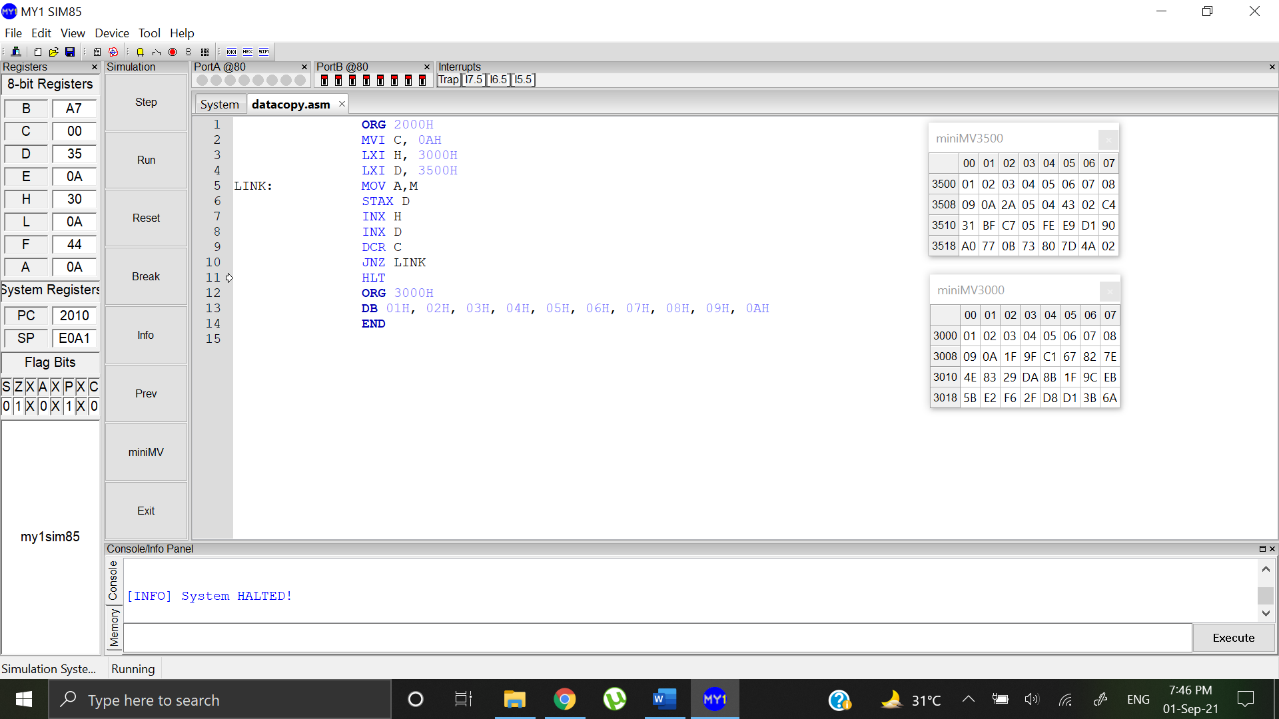

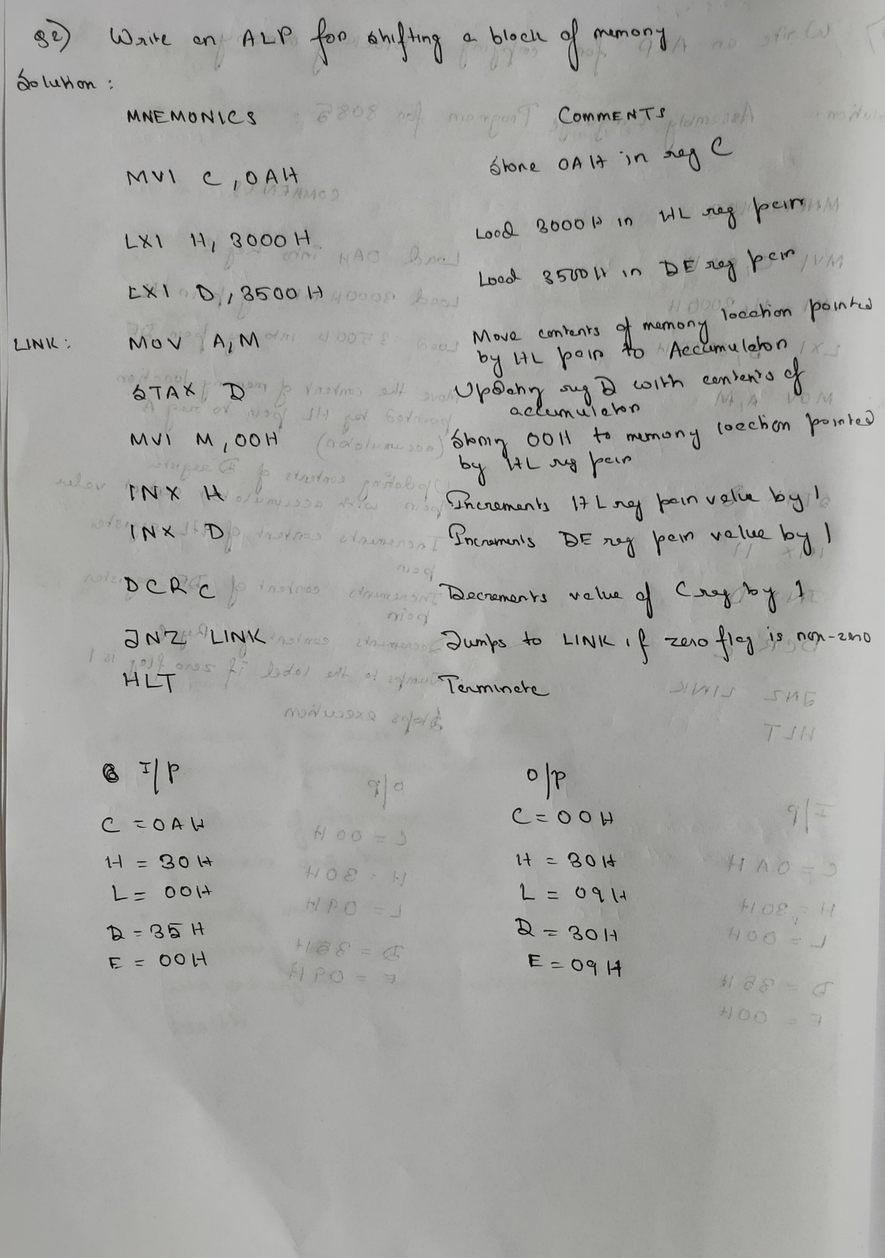

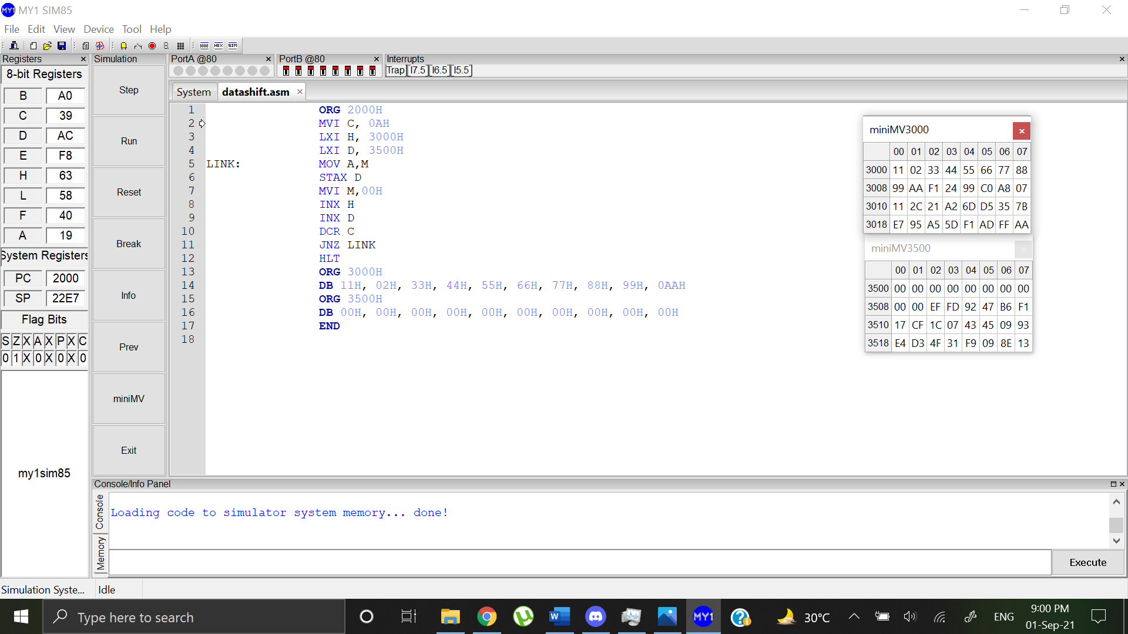

MV value before shift MV Value after shift

 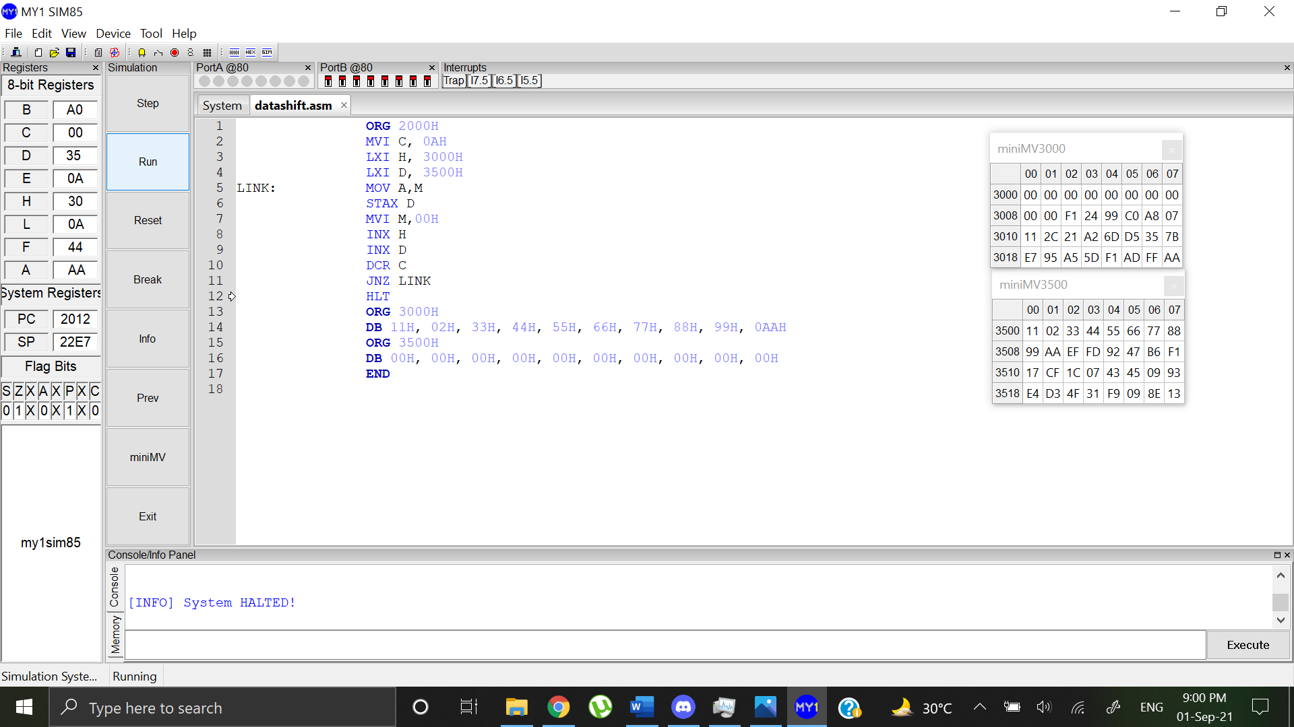

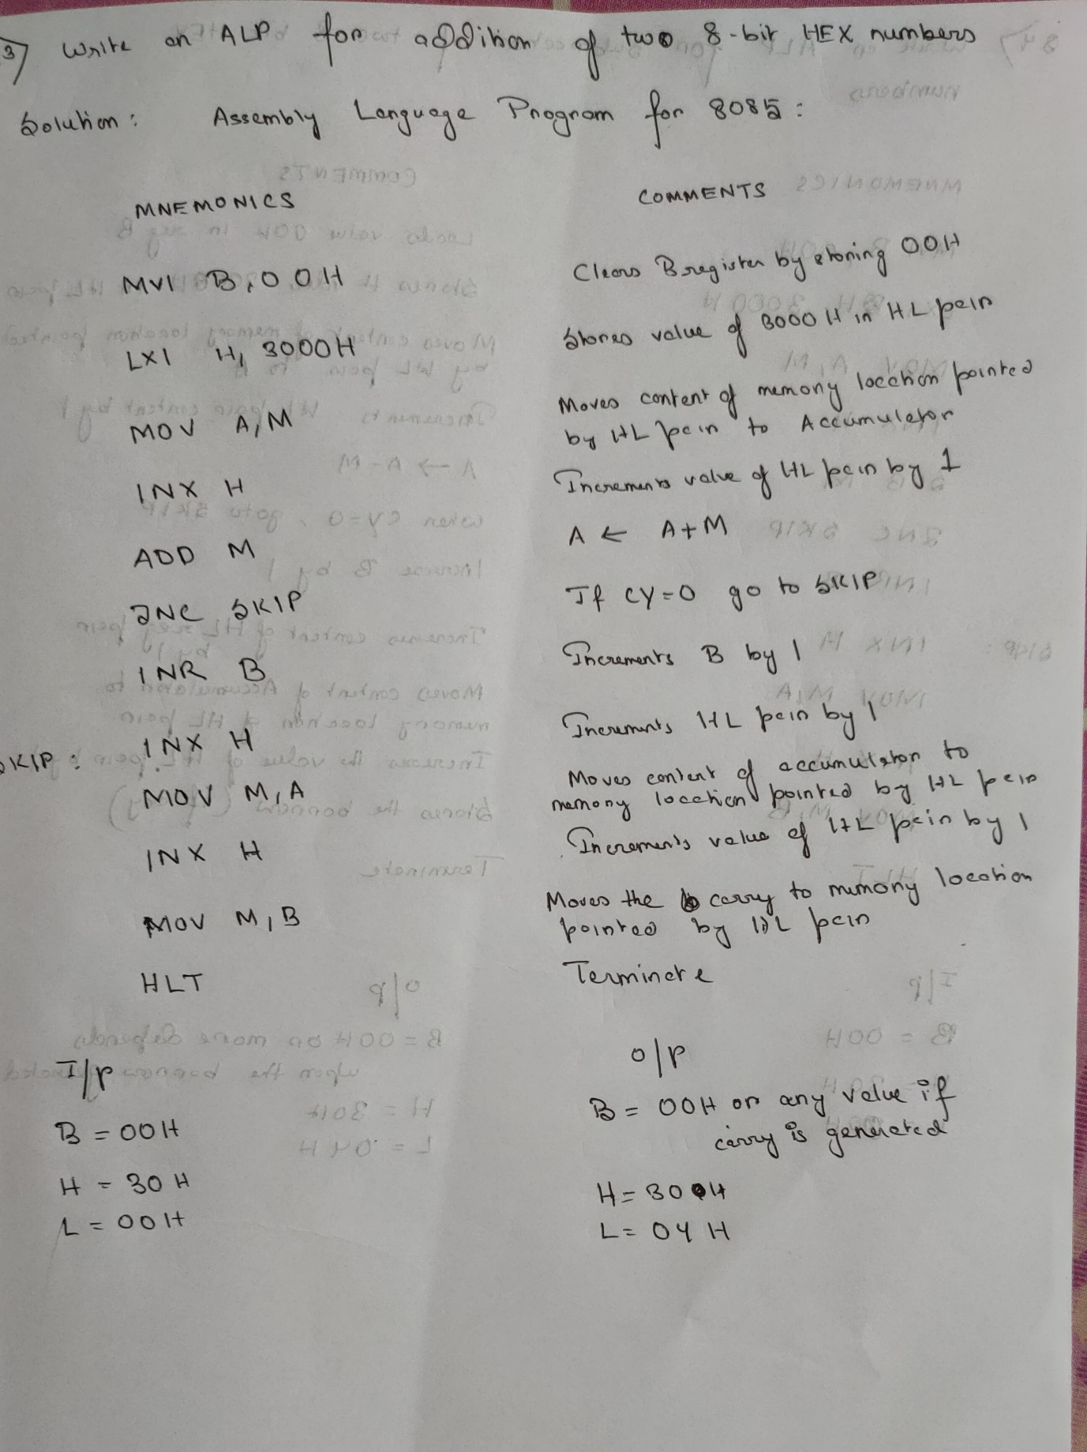

Edit: At output Value of L will be 03H

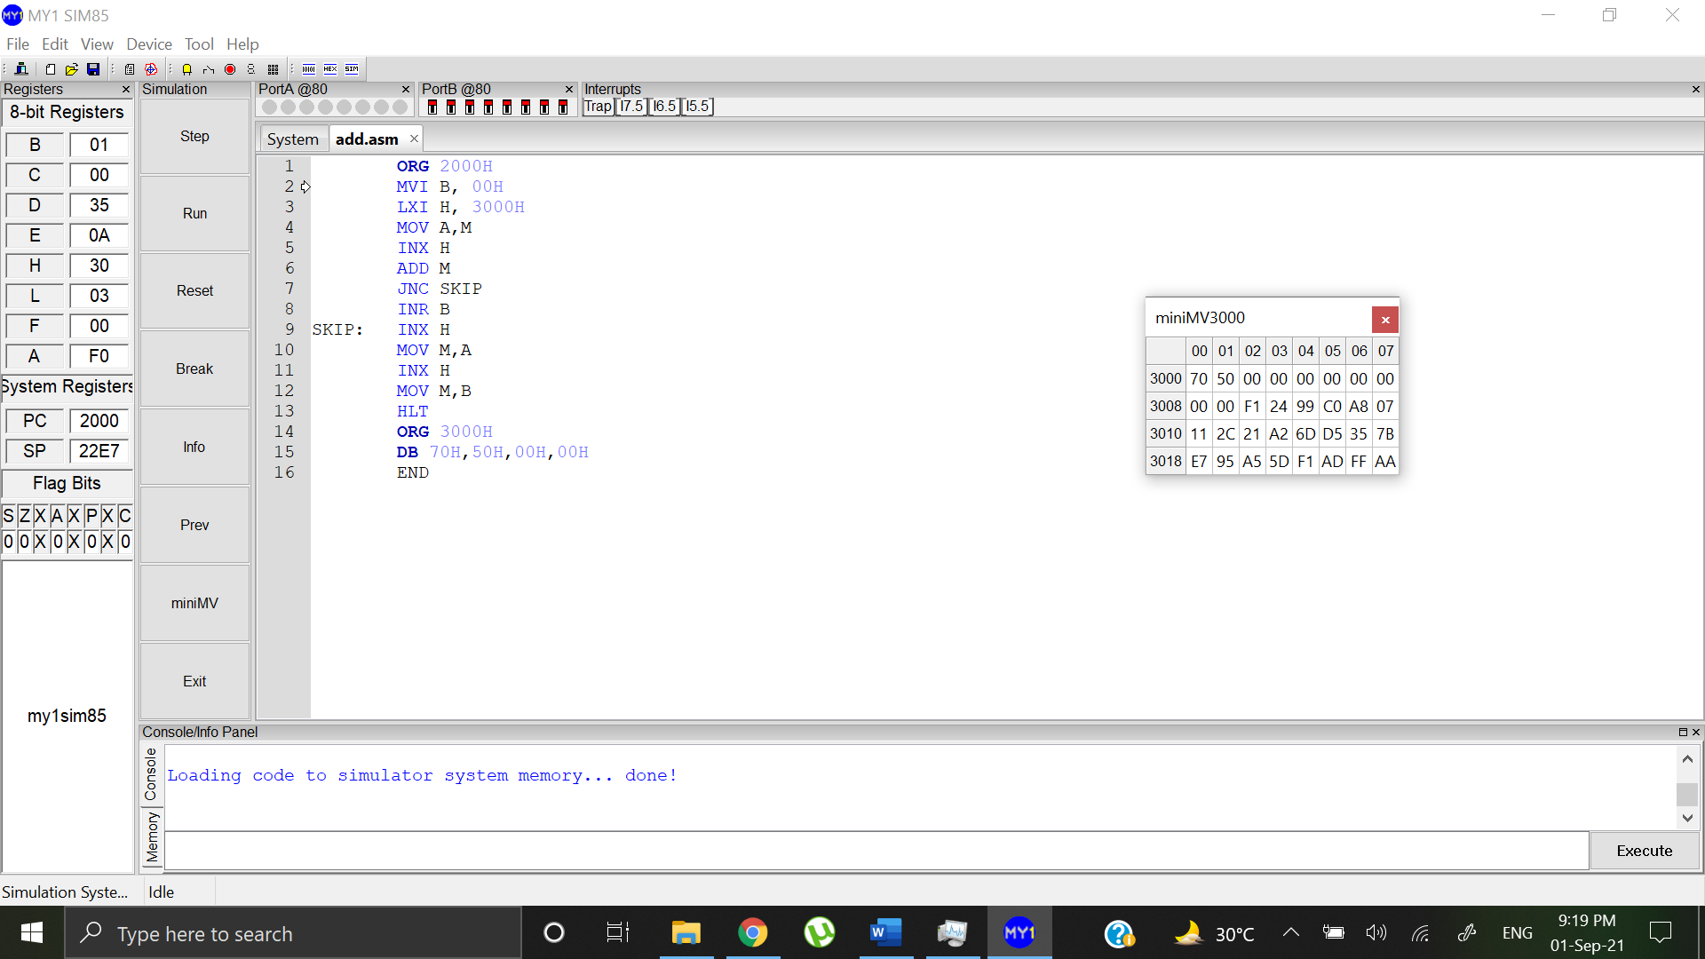

MV Value before addition MV Value after addition

 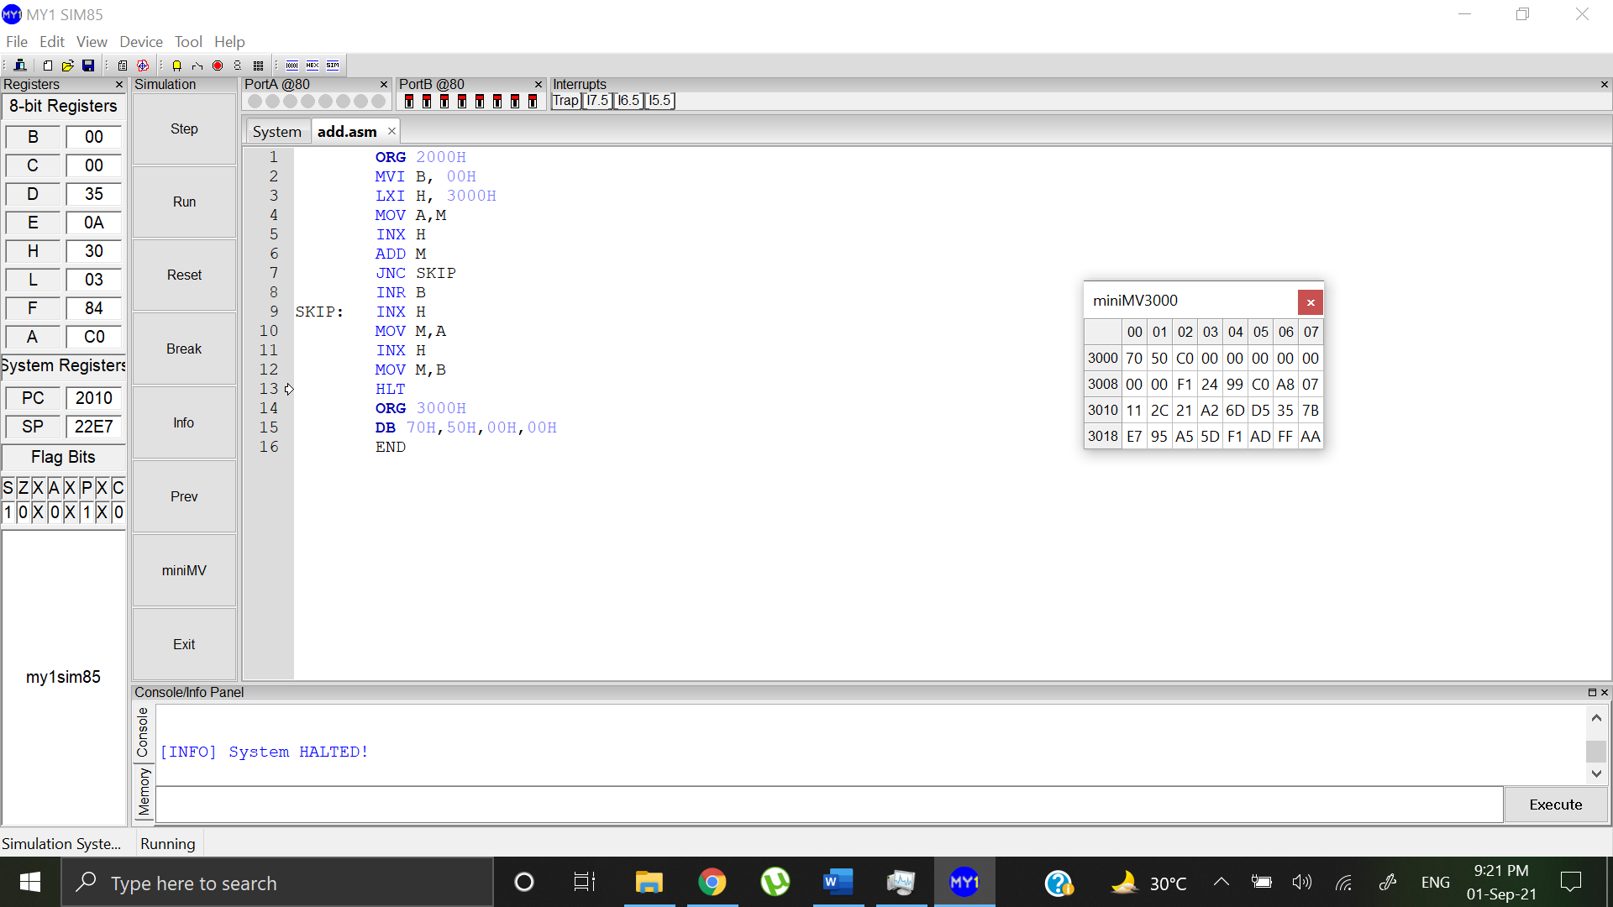

The addition value is stored in memory location 3002H and the value of carry is stored in memory location 3003H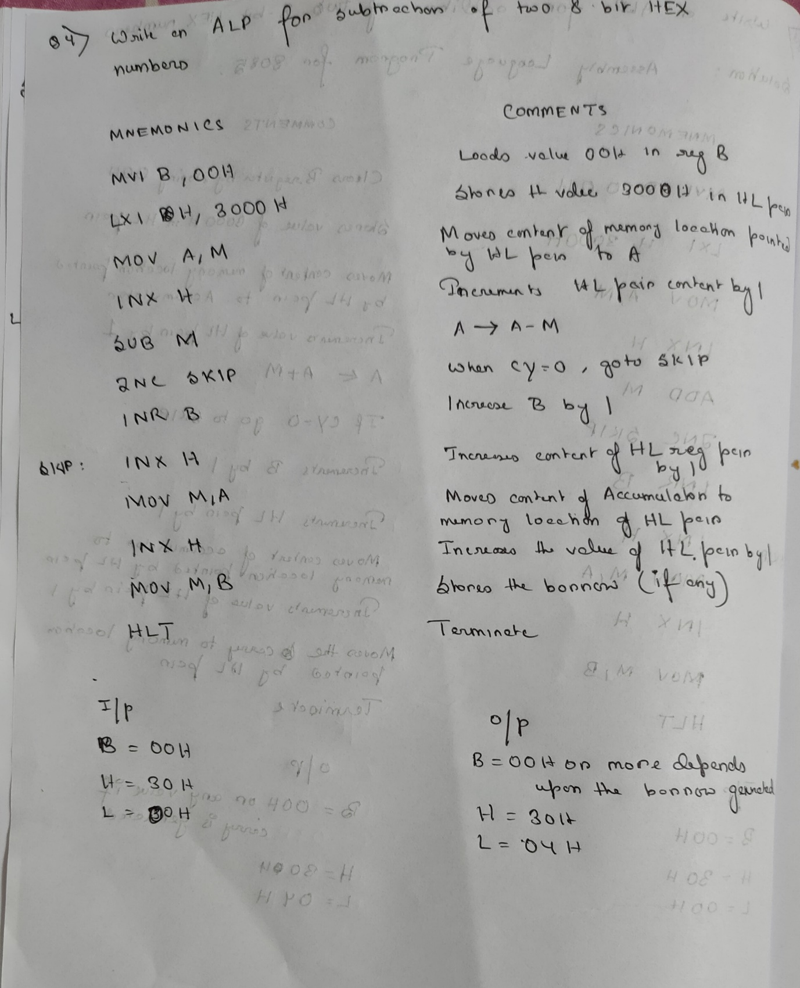

Edit: The value of L register at output will be 03H

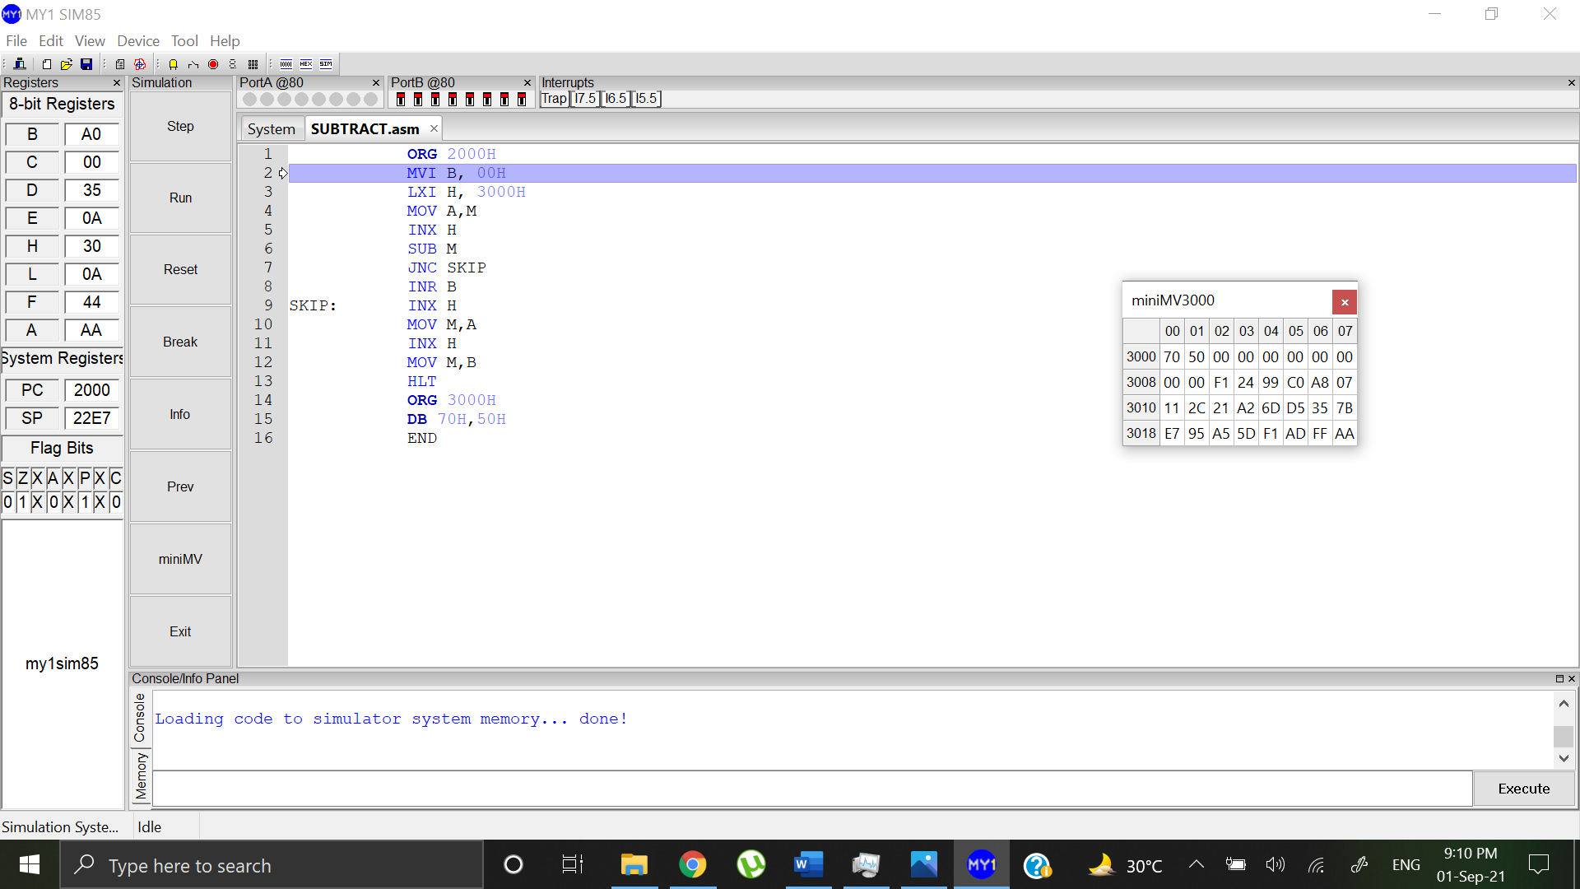

MV value before subtraction MV value after subtraction

 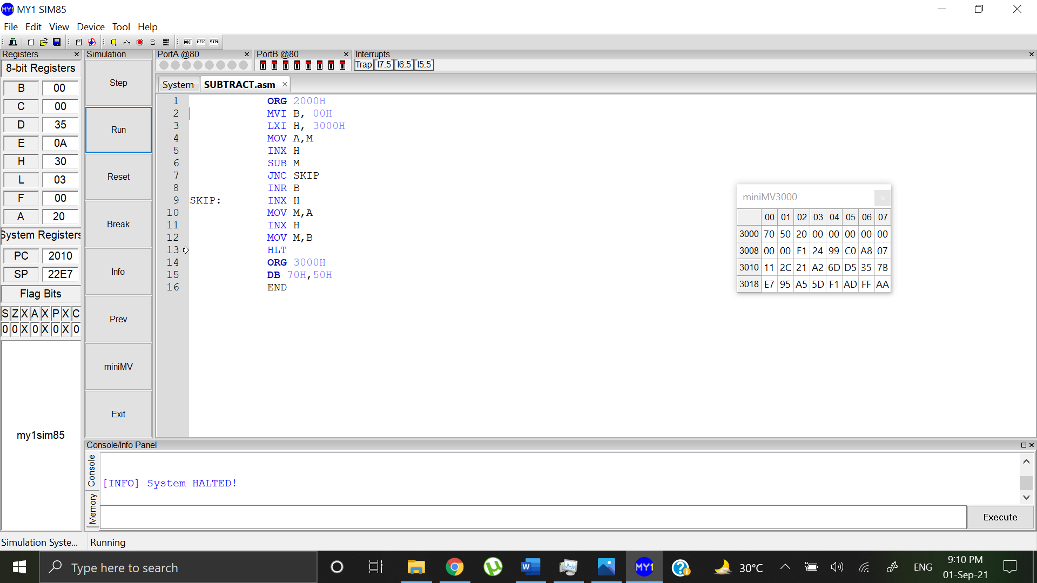

The subtracted result will be stored in the memory location 3002H and the borrow will be stored at location 3003H